PIZZA SALES SQL QUERIES
A. KPI’s Requirement
We need to analyze key for our pizza sales data to gain insight into our business performances specifically, we want to calculate the following metrics:

1. Total Revenue: The sum Of the Total Price of pizza orders.
SELECT SUM(total_price) AS Total_Revenue FROM pizza_sales;
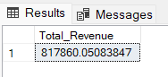
2. Average Order Value: The average amount spent per order, calculated by didviding the total revenue by the total number of orders.
SELECT (SUM(total_price) / COUNT(DISTINCT order_id)) AS Avg_order_Value FROM pizza_sales
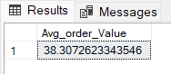
3. Total Pizzas Sold : The sum of the quantities of all pizza sold.
SELECT SUM(quantity) AS Total_pizza_sold FROM pizza_sales
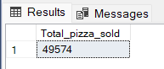
4. Total Orders: The total number of orders placed.
SELECT COUNT(DISTINCT order_id) AS Total_Orders FROM pizza_sales
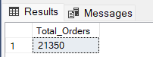
5. Average Pizzas per Order: The average number of pizzas sold per order,
Calculated by dividing the total number of pizzas sold by the total number of orders.
SELECT CAST(CAST(SUM(quantity) AS DECIMAL(10,2)) /
CAST(COUNT(DISTINCT order_id) AS DECIMAL(10,2)) AS DECIMAL(10,2))
AS Avg_Pizzas_per_order
FROM pizza_sales
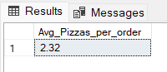

6. Hourly Trend for Total Pizza Sold

Select datapart(hour,order_time) as order_hour, sum(quantity) as Total_Pizza_sold from pizza_sales group by datepart(hour, order_time) order by datepart(hour, order_time);
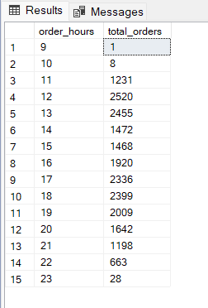

Charts Requirement

B. Daily Trend for Total Orders
SELECT DATENAME(DW, order_date) AS order_day,
COUNT(DISTINCT order_id) AS total_orders
FROM pizza_sales
GROUP BY DATENAME(DW, order_date)
Output:
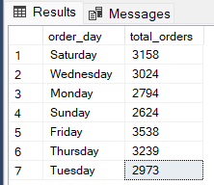
C. Monthly Trend for Orders
select DATENAME(MONTH, order_date) as Month_Name,
COUNT(DISTINCT order_id) as Total_Orders
from pizza_sales
GROUP BY DATENAME(MONTH, order_date)

Output
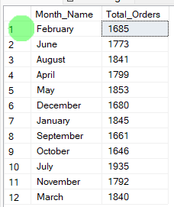

D. % of Sales by Pizza Category
SELECT pizza_category, CAST(SUM(total_price) AS DECIMAL(10,2)) as total_revenue,
CAST(SUM(total_price) * 100 / (SELECT SUM(total_price) from pizza_sales) AS DECIMAL(10,2)) AS PCT
FROM pizza_sales
GROUP BY pizza_category
Output
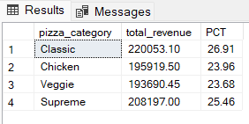
E. % of Sales by Pizza Size
SELECT pizza_size, CAST(SUM(total_price) AS DECIMAL(10,2)) as total_revenue,
CAST(SUM(total_price) * 100 / (SELECT SUM(total_price) from pizza_sales) AS DECIMAL(10,2)) AS PCT
FROM pizza_sales
GROUP BY pizza_size
ORDER BY pizza_size
Output
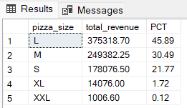
F. Total Pizzas Sold by Pizza Category
SELECT pizza_category, SUM(quantity) as Total_Quantity_Sold
FROM pizza_sales
WHERE MONTH(order_date) = 2
GROUP BY pizza_category
ORDER BY Total_Quantity_Sold DESC
Output
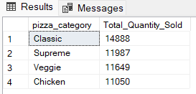
G. Top 5 Pizzas by Revenue
SELECT Top 5 pizza_name, SUM(total_price) AS Total_Revenue
FROM pizza_sales
GROUP BY pizza_name
ORDER BY Total_Revenue DESC
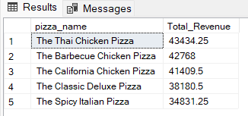
H. Bottom 5 Pizzas by Revenue
SELECT Top 5 pizza_name, SUM(total_price) AS Total_Revenue
FROM pizza_sales
GROUP BY pizza_name
ORDER BY Total_Revenue ASC
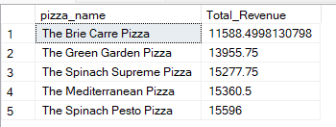
I. Top 5 Pizzas by Quantity
SELECT Top 5 pizza_name, SUM(quantity) AS Total_Pizza_Sold
FROM pizza_sales
GROUP BY pizza_name
ORDER BY Total_Pizza_Sold DESC
Output
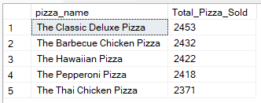
J. Bottom 5 Pizzas by Quantity
SELECT TOP 5 pizza_name, SUM(quantity) AS Total_Pizza_Sold
FROM pizza_sales
GROUP BY pizza_name
ORDER BY Total_Pizza_Sold ASC
Output
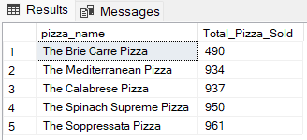

K. Top 5 Pizzas by Total Orders
SELECT Top 5 pizza_name, COUNT(DISTINCT order_id) AS Total_Orders
FROM pizza_sales
GROUP BY pizza_name
ORDER BY Total_Orders DESC
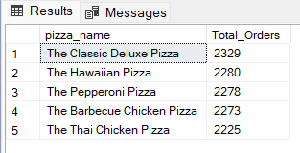
L. Borrom 5 Pizzas by Total Orders
SELECT Top 5 pizza_name, COUNT(DISTINCT order_id) AS Total_Orders
FROM pizza_sales
GROUP BY pizza_name
ORDER BY Total_Orders ASC
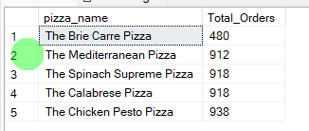
NOTE
If you want to apply the pizza_category or pizza_size filters to the above queries you can use WHERE clause. Follow some of below examples
SELECT Top 5 pizza_name, COUNT(DISTINCT order_id) AS Total_Orders
FROM pizza_sales
WHERE pizza_category = 'Classic'
GROUP BY pizza_name
ORDER BY Total_Orders ASC

If you want to apply the Month, Quarter, Week filters to the above queries you can use WHERE clause. Follow some of below examples
SELECT DATENAME(DW, order_date) AS order_day, COUNT(DISTINCT order_id) AS total_orders
FROM pizza_sales
WHERE MONTH(order_date) = 1
GROUP BY DATENAME(DW, order_date)

*Here MONTH(order_date) = 1 indicates that the output is for the month of January. MONTH(order_date) = 4 indicates output for Month of April.

SELECT DATENAME(DW, order_date) AS order_day, COUNT(DISTINCT order_id) AS total_orders
FROM pizza_sales
WHERE DATEPART(QUARTER, order_date) = 1
GROUP BY DATENAME(DW, order_date)

*Here DATEPART(QUARTER, order_date) = 1 indicates that the output is for the Quarter 1. MONTH(order_date) = 3 indicates output for Quarter 3.

